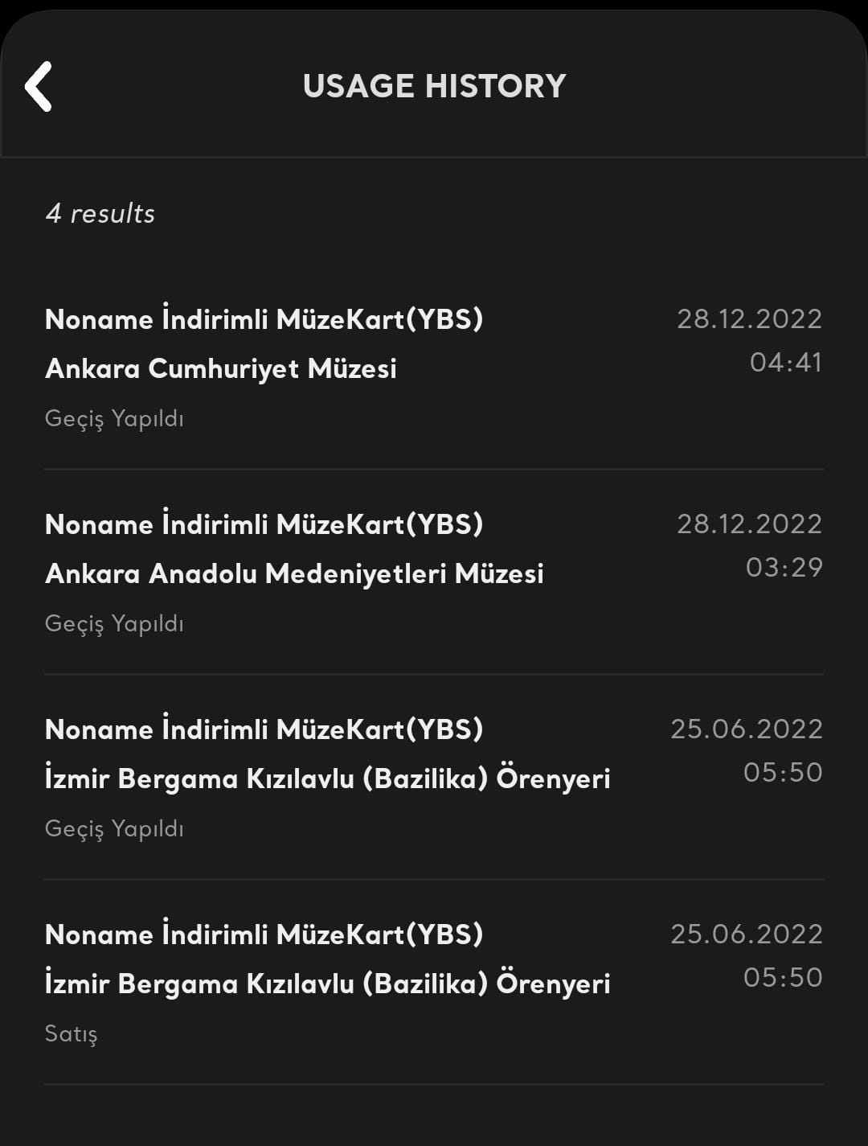

As a proof of this event, I wanted to use the purchase history screen from the museum card mobile app. I do not know the reason but in the history it says “no name” card. I suppose it is because of the fact that I register the system with my account after I got the card. So, I both put the photo of my muesum card and the screen shoot that shows “no name” card belongs to my account in the system of museum card.